**Furkan Deniz Albaylar**

INDUSTRİAL FURNACE CONTROL

Material List of This Project

* 1N4004 (Diode)
* ARDUINO MEGA 2556
* BC108(Transistor)
* BUTTON
* FAN DC
* LM35(Temperature sensor)
* LM041L(LCD)
* OVEN
* POT – HG(Potentiometer)
* RELAY
* RESISTORS (4*10KΩ)

GENERAL EXPRESSION OF INDUSTRIAL FURNACE CONTROL SYSTEM

Firstly, this project was simulated in a Proteus with using Arduino Mega 2556. After we drew all the components of our circuit diagram. In developing this program, we used Arduino IDE. After developing our code, we compile the project to Proteus's Arduino Mega 2556 card. We installed the code and run this program.

DESCRIPTION OF PROJECT

First, in our project, we focused on the simulation of an industrial furnace (oven). We prepared a set the value to decide an oven’s degree of temperature. In our project set value is 25 degrees. We set 25 degrees using Arduino IDE (Figure-1).metin içeren bir resim

Açıklama otomatik olarak oluşturuldu

Figure-1-Arduino IDE code

If you want to change you can change the set point in an Arduino code part. Secondly, When the temperature should be above the set point, the oven should be cooling. An engine fan was used for the cooling system (Figure-2). The Arduino code of this project is shown below (Figure-3).

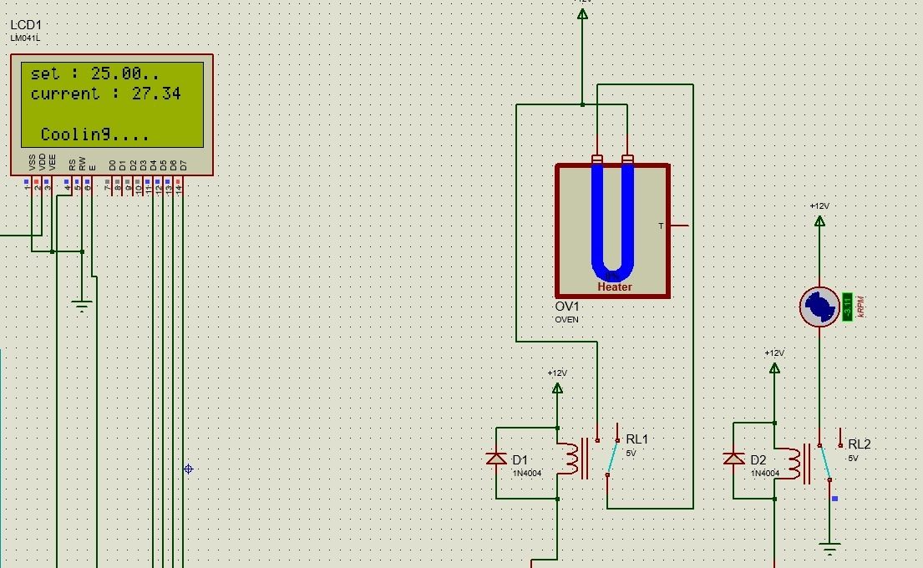

Figure-2 (Oven passive, DC Motor active)

Arduino Code for Oven passive, DC Motor active

metin içeren bir resim

Açıklama otomatik olarak oluşturuldu

Figure-3-If statement for activating DC Fan

The oven operates when the oven drops below the set point. In this project, an oven was used for increasing of current temperature (Figure-4). The Arduino code of this project is shown below. (Figure-5)

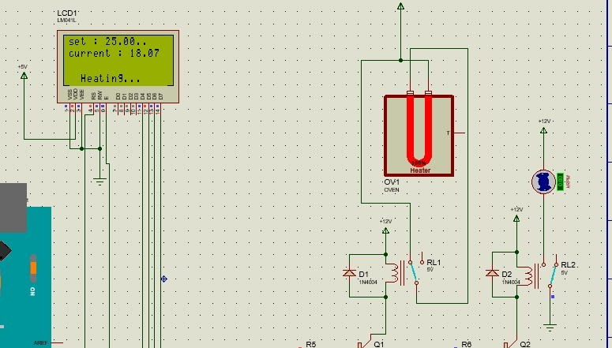

Figure-4 (Oven active, DC Motor passive)

Arduino code for Oven active, DC Motor passive

metin içeren bir resim

Açıklama otomatik olarak oluşturuldu

Figure-5- If statement for activating Heater

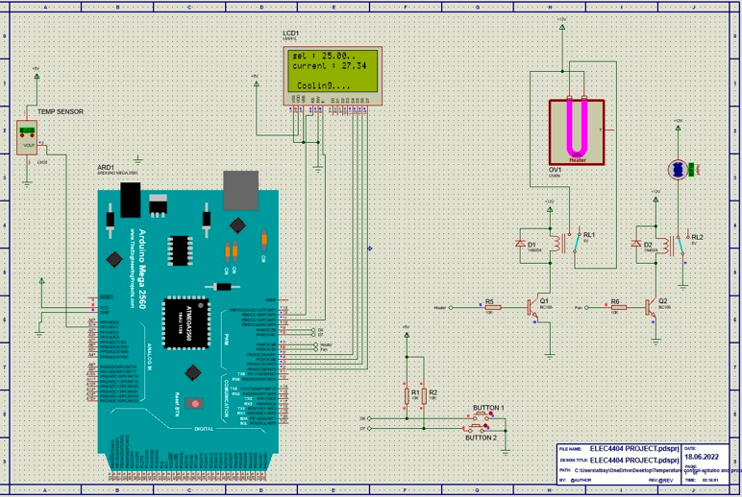**View of Project**